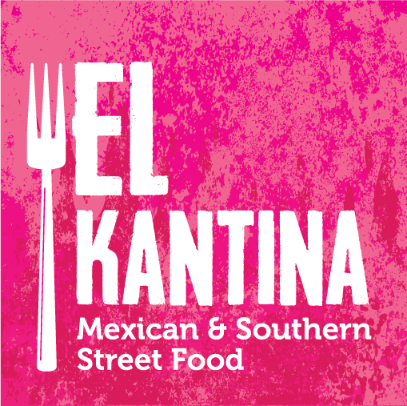

Terms and Conditions – from June 2018

- Booking Your Date with El Kantina
  - All event bookings must be confirmed in writing by the Client.
  - A booking deposit is required to secure El Kantina for the date of your event (this deposit is non-refundable should your event be cancelled, see below)
  - All bookings are subject to minimum guest numbers, these will be confirmed in writing by El Kantina to the Client.

- Booking Deposit
  - A booking deposit figure will be provided to the Client in writing by El Kantina once your booking confirmation is received. This deposit will be deducted from the total event costs which will be issued to the Client no later than two months prior to the event (please see our Payment terms below).
  - Payment methods available include bank transfer, cheque and cash.

- Additional Deposit
  - An additional deposit will be required for all non-service bookings when black trays, glassware, crockery or utensils etc. are provided by El Kantina for use by the Client during their event.
  - £100.00 will be added to the total event costs (and processed with the booking deposit above) and refunded via bank transfer following the return of all items (in full and undamaged) to El Kantina . Any items not returned will be chargeable and the additional deposit will not be refunded.
- Booking Confirmation
  - Once the Clients deposit/s have been received a receipt will be issued by El Kantina together with a formal confirmation letter which will include your draft menu, event summary and estimated costs based on the number of guests and selections made by the Client.
  - Once a date has been secured a client tasting session is possible for bookings with a minimum of 100 guests [fee maybe payable for bookings >100]. Sessions can be arranged from October to April and are subject to the event type and menu selected.
- Variations to the Price
  - All bookings are subject to minimum guest numbers which will be confirmed by El Kantina at the time of booking.
  - Where children are attending – if over 7 years of age they are payable at the same rate as adults, if under 7 years of ages they are chargeable at half the adult price (subject to minimum numbers mentioned above). Children under 3 years will be free of charge.
  - Any variation to menu selections for children must be discussed with El Kantina as soon as possible so menus can be revised accordingly.
- Payment of Total Event Costs Prior to Event
  - Payment in full is required for all catering services to be provided by El Kantina prior to the event. Final guest numbers must be confirmed to El Kantina no later than two months prior to the event.
  - The information provided at this point will be used to produce your total event cost invoice, arrange staff and co-ordinate with your venue. Once our invoice is received by the Client payment must be received no later than two weeks before the event. After final numbers have been provided to El Kantina we are happy to accept any increases in requirements however no reduction will be possible.
  - Should El Kantina be advised of any increases following payment and less than two weeks prior to the event, El Kantina reserve the right to accept these and will raise an additional invoice following the event for these guests or extras food needed, payment will then be due for immediate settlement by the Client.
  - As cancellation insurance is not available to a catering supplier, the Client is advised to arrange such insurance to recover their losses.
- Cancellation Charges
  - In the unfortunate event of a booking having to be cancelled confirmed in writing will be needed by the Client. Your deposit will be retained and the following charges will be incurred
    - Cancellation received with less than two months notice prior to the event – 50% of the total event cost
    - Cancellation received less than one month prior to the event – 100% of the total event cost
  - The total event cost will be based on the number of confirmed guests attending at the agreed price per head. Should guest numbers be unconfirmed at the time of cancellation the total event cost will be based the originally quoted/estimated guests numbers.
  - Any additional costs incurred by El Kantina in preparation of the event up until the time of cancellation will be charged to the Client. This is to cover any losses caused to El Kantina for administration costs, travel, supplies etc. and will be discussed fully in event of cancellation.
  - No cancellation charges are incurred where the booking is transferred to a new date
- Dietary Requirements and Allergies
El Kantina will endeavour to provide suitable adaptions to the Clients menu for any guests with special dietary requirements or allergies. We cannot however take responsibility for any guests unless advised in advance (no less than one month prior to the event).
- Clients Food and Drinks
  - We accept no liability for any food supplied to the Client by another caterer (or food products suppliers by the Client themselves) in additional to those arranged by El Kantina.
  - Where the Client has made additional arrangements (for example an evening hog roast) El Kantina will require a Food Disclaimer Form to be completed and returned no later than one month prior to the event.
  - El Kantina will happily serve a Clients arrival drinks, table wines etc. during their event subject to waitress fees or corkage, please ask for further details.
- Client’s use of El Kantina’s Property and Clients Personal Property or Gifts
  - The Client agrees to pay for any loss or damage to any equipment, crockery, cutlery or glassware supplied by El Kantina for the event, including any issues caused by the Client guests[n/a for Palm Leaf crockery and cutlery.
  - The use of candles by the Client for centre pieces or decoration where El Kantina have supplied table linen is strictly prohibited.
  - Any damaged linen because of the use of felt tip pens will result in an additional charge payable by the Client after the event (a separate area for colouring can be arranged with suitable table coverings, please ask for details)
  - El Kantina will not be held responsible for the theft, lost or damage to any personal effects of the Client or gifts brought onto premises by the Client guests.
- Liability of El Kantina
El Kantina accept no liability under any claim whatsoever (be it by negligence or otherwise) arising from any loss over the figure of the existing El Kantina Public Liability Limit of Indemnity. Note that this figure, which may change from time to time, is available upon request.
- GDPR and Privacy Policy
El Kantina are fully compliant with the General Data Protection Regulations (GDPR) and our Privacy Policy falls in line with Regulations, to request a copy please contac via email at info@elkantina.co.uk or visit our website www.elkantina.co.uk
- Force Majeure
El Kantina shall incur no liability to the Client if performance of the contract is prevented or hindered by any case whatsoever beyond El Kantina’s control and in particular but without prejudice to the generality of the foregoing, by act of fire, flood, subsidence, sabotage, accident, strike, or lock out and shall not be liable for any loss or damage resulting there from suffered by the Client.
- Future Changes to Terms and Conditions
El Kantina reserve the right to change our Terms and Conditions when necessary due to the continual evolving nature of our business. It is your responsibility to ensure that you are up to date with our Terms and Conditions.

